BlogLink

Using Memcached as Distributed Cache in .NET Core - .Net Core Central (dotnetcorecentral.com)

Using IMemoryCache to cache data in-memory using .NET 5 [An Introduction]
(4) Using IMemoryCache to cache data in-memory using .NET 5 [An Introduction] - YouTube

Inject dependencies in Startup.cs

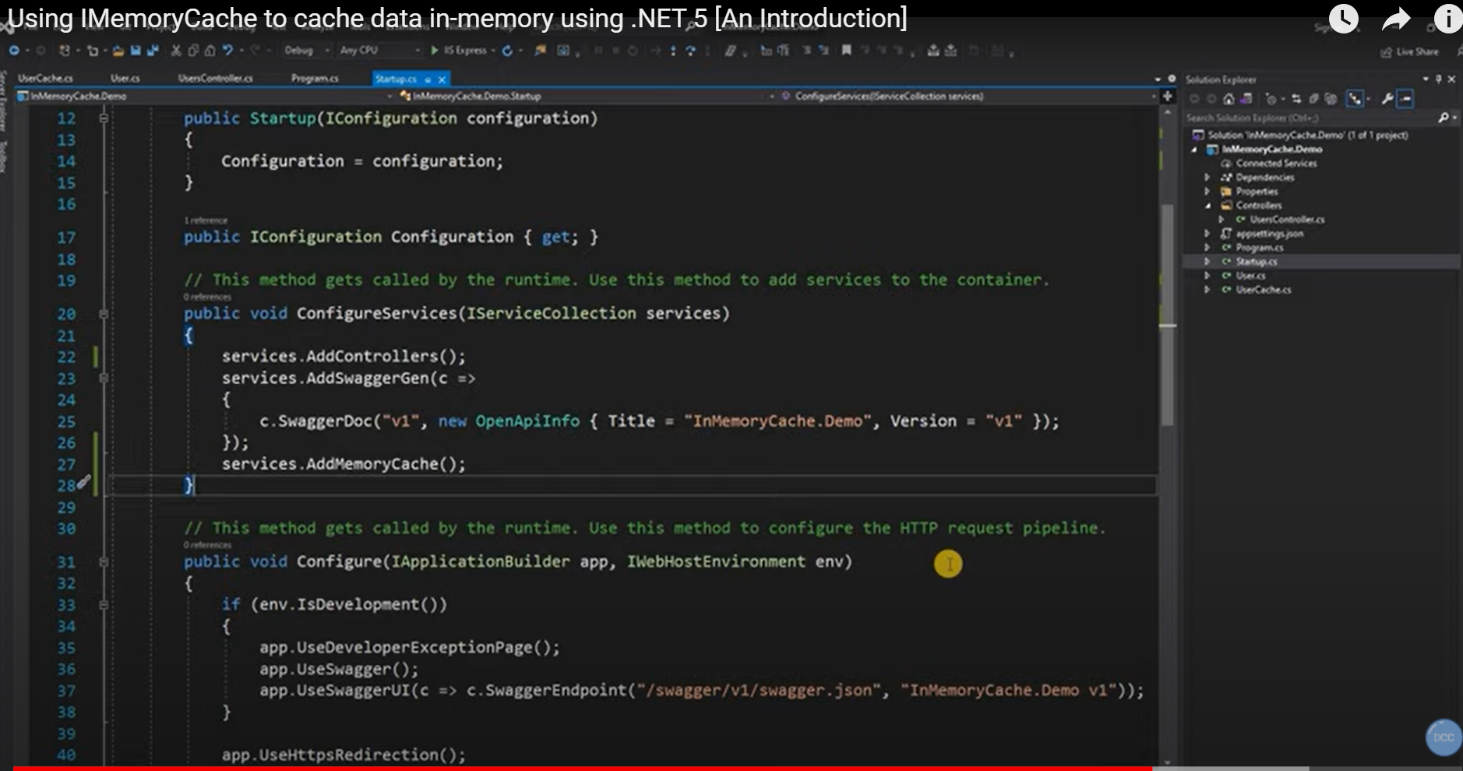

Sliding and Absolute
Sliding – if accessed in given (30 sec) time then it will get extended again and again
Absolute - after the time reached (90 sec here) will get expired

IMemoryCache : Microsoft.Extension.Caching.memory

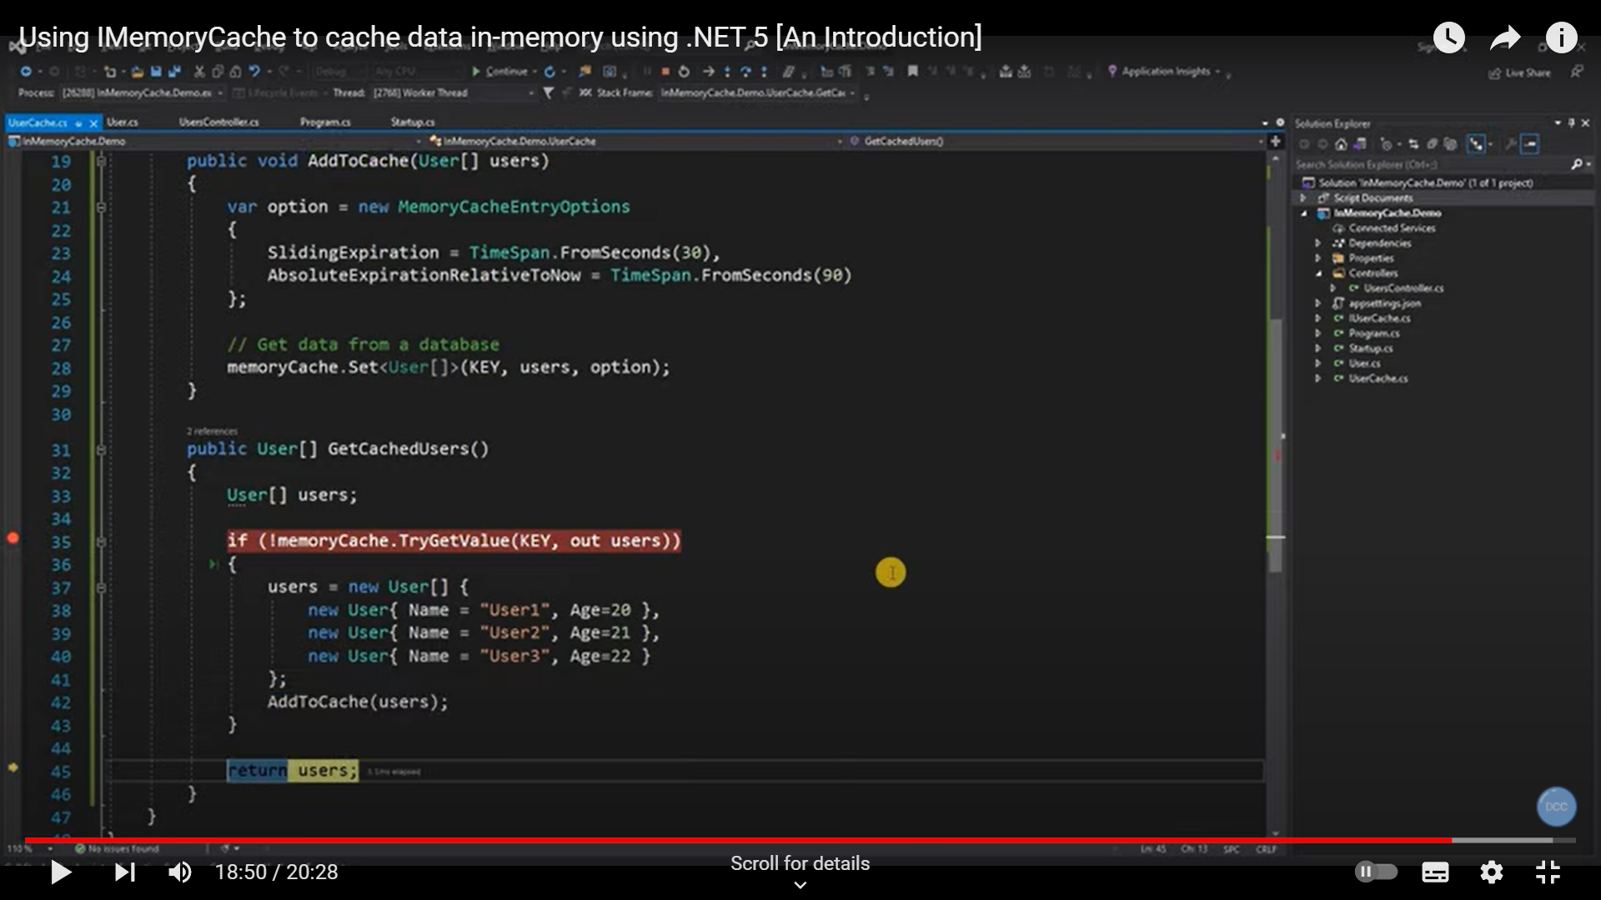

Memcached as Distributed Cache in .Net Core Application
(4) Memcached as Distributed Cache in .Net Core Application - YouTube

C:\ > docker pulled Memcached
C:\ > Docker images
C:\ > Docker run -p 11211:11211 -d Memcached

NUGET package - EnyinMemcachedCore
Redis or Memcached can be used so we will use our own class like
CacheProvider and

Using Enyim.Caching;
Internal class CachePRovider
{
Public CacheProvider(ImemcachedClinet memcacheClient)
}

ContainerConfiguration
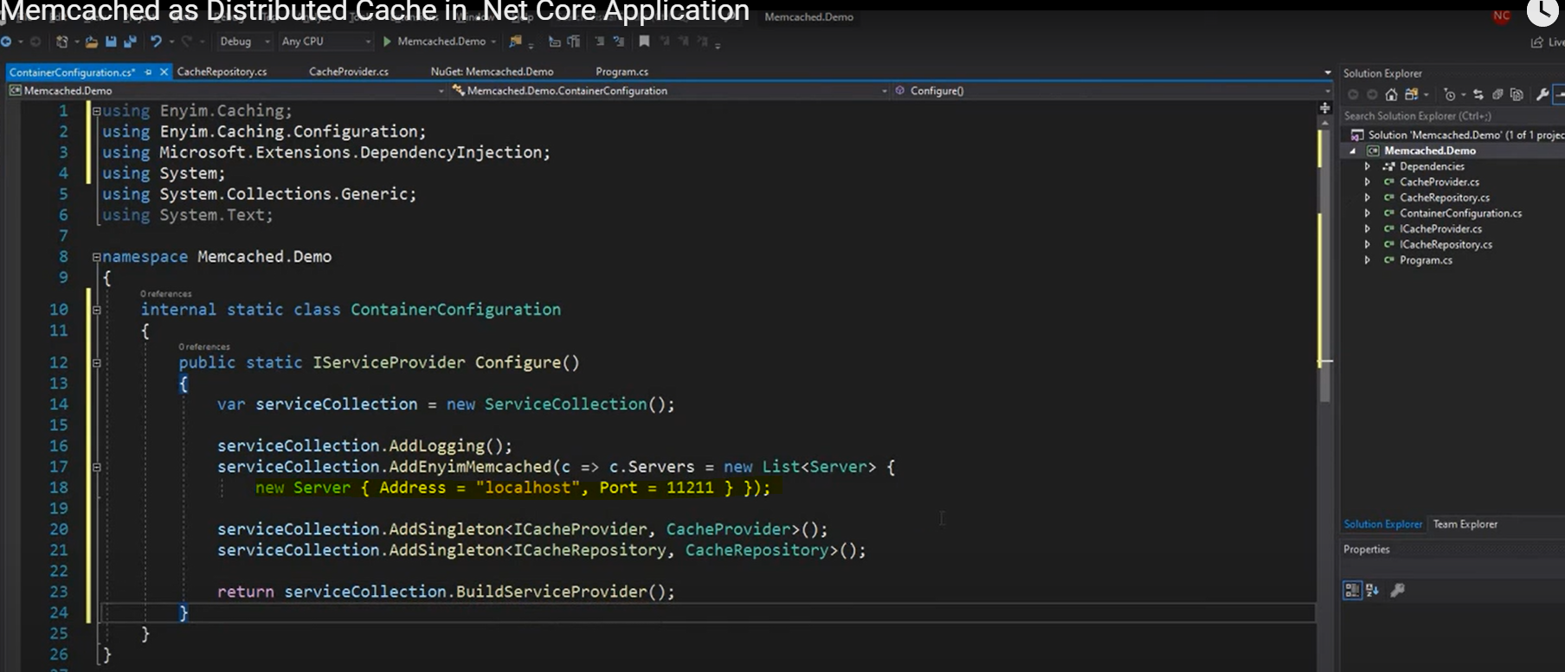

Get and set Cache
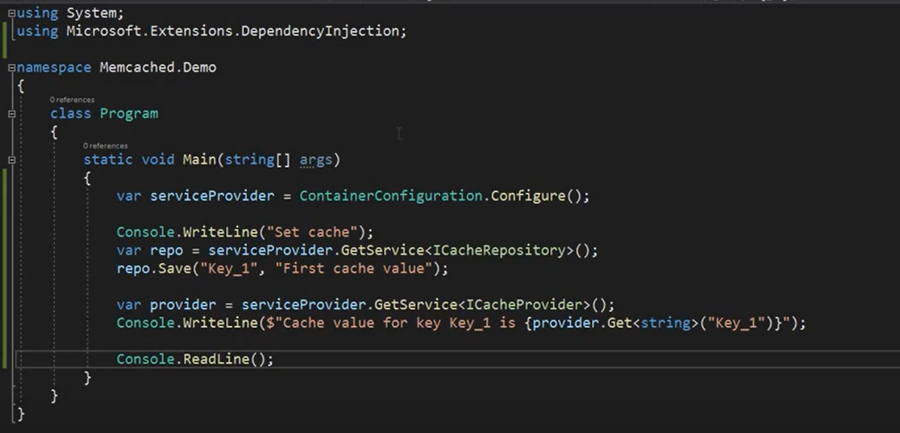

IDistributedCache from Microsoft.Extensions.Caching.Distributed

Bulk insert data into SQL Server using SqlBulkCopy class

(4) Extremely easy way to bulk insert data into SQL Server using SqlBulkCopy class - YouTube

